Big Mountain Resort Report

Problem:

Can the Big Mountain resort maintain its profit margin of 9.2% (1,540,000 in addition to last season) this season after its recent expansion to install an additional chair lift by increasing the ticket prices, the maximum number of runs, or both?

Summary:

Based on our research on ticket price, we believe that the Big Mountain resort can increase its adult weekend price from 81 dollars to 88 dollars without overcharging our customers. We are assuming that over 350,000 people are coming to ski and snowboard at Big Mountain Resort this year and the fact most visitor comes during the weekend. This increase can increase revenue margin by roughly 8.6 percent, which nearly covers the profit margin requires to compensate for the increase in operation cost.

Analysis:

Our analysis involves using a linear regression model and cluster analysis to compare Big Mountain Resort against other 331 ski resorts in the US. The comparison includes ticket prices, maximum of runs, total skiable area, and many more. From a top-down perspective, when comparing to other resorts, Big Mountain Resort is a high elevation resort. However, it has one of the lowest summit elevations out of all high elevation resorts. Also, it has a top 3 highest vertical drop out of all the resorts in this analysis. Base on this information, we understand that Big Mountain Resort has a unique advantage that allows skiers to enjoy one of the best ski trails without needing to climb up to great height.

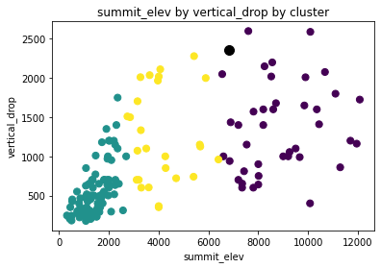

Figure 1) the figure shows a cluster analysis comparing big mountain resort (Black) to other resorts in US. Based on K Mean Cluster, Big Mountain resort is considered a high elevation resort (Purple)

In terms of ticket price analysis, we found out that two of the most influential factors that affect ticket prices are the number of Runs the resort can handle and the average snowfall of the resort. When we perform cluster analysis and plot these two variables against adult weekend ticket prices, we noticed that our resort is currently providing service at a relative discount when compared to other resorts. If you look at average run provided each day, Big Mountain Resort delivers on average over 100 runs per day, which beats its closest competitors by ten runs. Yet, our tickets are not even the steepest price. Furthermore, when comparing the average snowfall, which is an indication of the quality of snow track, the Big Mountain resort is still among the top 10. Based on this fact, in addition to our recent expansion, I believe it is acceptable for the Big Mountain Resort to increase its Weekend ticket price from 81 dollars last season to 88 while remain financially competitive.

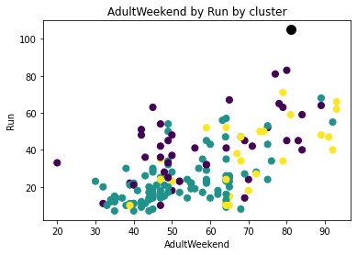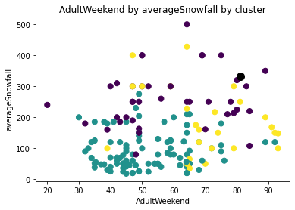

Figure 2 (left) The figure plots the ticket price of the weekend against the number of runs on the resort. Big mountain resort (in Black) provides an outlier amount of Runs compares to other resort. Yet, its ticket price still remains competitive.

Figure 3 (right) The figure plots the ticket price of the weekend against average annual snowfall. Big mountain resort (in Black) is one of the resort with top 10 annual snowfall in this analysis